SHANNON SULLIVAN





CHANCE DUNN



GLEN FORMAN



FRANK MURGOLO



RON MOORE holding EX1 in Gates Housing

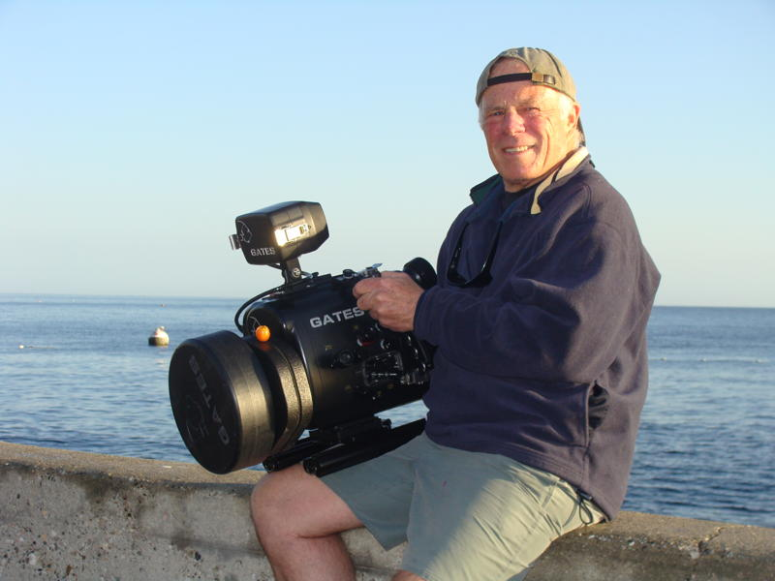

RON MOORE and CHAD STONE



CONNIE RAE (edit as you choose) I’ll take a new picture soon

